Blessed Sacrament Catholic Primary School.

Whole School Approach Mental Health and Emotional Wellbeing Policy
2021
“Aim high – live life to the full”
Written By | CAMHS Liverpool
Ratified by Governors | November 2021
Date for review | November 2023
Signed Chair of Governors | T Gunderson
Signed Headteacher | C Davey

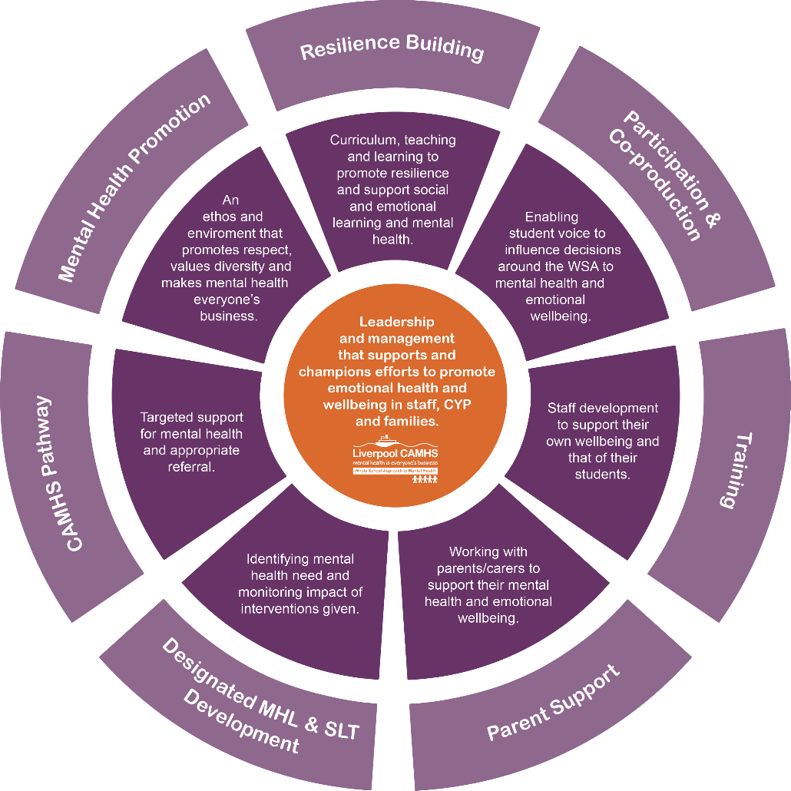
Contents

- Policy Statement
- Scope
- Policy Aims
- Key Staff Members
- Levels of need
5.1 Individual Care Plans
- Mental Health Promotion
- Signposting
- Our School Mental Health Pathway
- Recognising signs and symptoms of mental distress
- Targeted support
- Managing disclosures
- Confidentiality
- Parents/Carers
  - Working with Parents/Carers
  - Supporting Parents/Carers
- Support Peers
- Training
- Policy Review

Policy statement

At Blessed Sacrament Catholic Primary School, we are committed to promoting a whole school approach to positive mental health and emotional wellbeing for all students, their families and members of staff and governors. Our open culture allows students’ voices to be heard, and through the use of effective policies and procedures we ensure a safe and supportive environment for all affected - both directly and indirectly - by mental health issues.

2.0 Scope

This policy is a guide to all staff – including non-teaching and governors – outlining Blessed Sacrament’s ) whole school approach to promoting mental health and emotional wellbeing. It should be read in conjunction with other relevant school policies.

3.0 Policy Aims

- Promote positive mental health and emotional wellbeing in all staff and students.
- Increase understanding and awareness of common mental health issues.
- Enable staff to identify and respond to early warning signs of mental ill health in students.
- Enable staff to understand how and when to access support when working with young people with mental health issues.
- Provide the right support to students with mental health issues, and know where to signpost them and their parents/carers for specific support.
- Develop resilience amongst students and raise awareness of resilience building techniques.
- Raise awareness amongst staff and gain recognition from SLT that staff may have mental health issues, and that they are supported in relation to looking after their wellbeing; instilling a culture of staff and student welfare where everyone is aware of signs and symptoms with effective signposting underpinned by behaviour and welfare around school.

4.0 Key staff members

This policy aims to ensure all staff take responsibility to promote the mental health of students, however key members of staff have specific roles to play:
- Whole School Approach Senior Mental Health Lead (Strategic)
- Designated Mental Health Lead/Team (Operational)
- School Commissioned Mental Health Staff
- Designated Safeguarding Lead
- SENCO
- ROAR/MHFA trained staff
- PSHE Coordinator

- External Education Mental Health Team (MHST, Seedlings, Wellbeing Clinic, Fresh CAMHS Senior Practitioner)

If a member of staff is concerned about the mental health or wellbeing of student, in the first instance they should speak to Jane Griffin / Safeguarding / Mental Health Team.

If there is a concern that the student is high risk or in danger of immediate harm, the school’s child protection procedures should be followed.

If the child presents a high-risk medical emergency, relevant procedures should be followed, including involving the emergency services if necessary.

5.0 Levels of Support

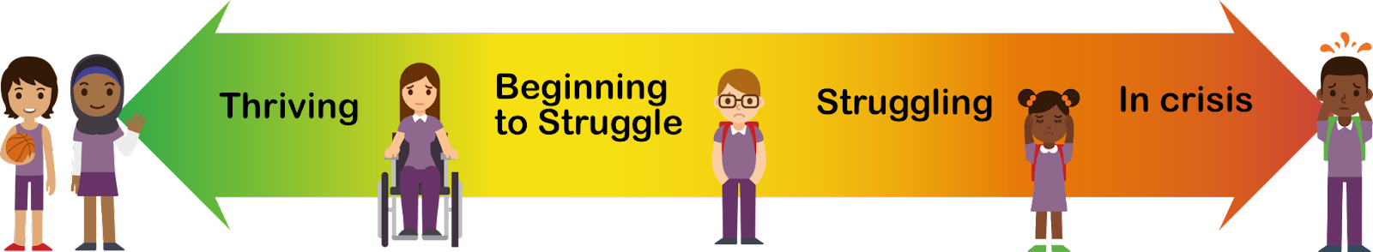
Levels of support are used to help education providers and services to determine the type of support that might be needed for children/young people. There are 4 levels:

Green = Thriving. This level is for all children and young people and represents the basic level of mental health awareness and support strategies that all children and young people need for positive emotional wellbeing.
Yellow = Beginning to struggle. At this level of need children/young people will be showing early signs of distress that may be the start of an emerging mental health issue. Short-term interventions that build coping strategies are given to prevent these issues from developing – small changes to prevent bigger challenges.
Orange = Struggling. At this level children and young people will need more specific support as their mental health problems will be more developed and significantly impacting their day-to-day life. There may also be other complexities such as trauma or neurodevelopmental conditions. Interventions are chosen to suit the needs of each child/young person and will vary in modality, and intensity.
Red = In Crisis. At this level children and young people will need high-level support for mental health conditions that require support from Alder Hey Fresh CAMHS. Children may be at crisis point, require medication, or several different types of specialist support.
Further guidance can be found in the WSA Levels of support Framework.

Green = Prevention and early identification. This level is for all children and young people and represents the basic level of mental health awareness and support strategies that all children and young people need for positive emotional wellbeing.
Yellow = Early Intervention. At this level of need children/young people will be showing early signs of distress that may be the start of an immerging mental health issue. Short-term interventions that build coping strategies are given to prevent these issues from developing – small changes to prevent bigger challenges.
Orange = Intervention. At this level children and young people will need more specific support as their mental health problem will be more developed and significantly impacting their day-to-day life. There may also be other complexities such as trauma or neurodevelopmental conditions. Interventions are chosen to suit the needs of each child/young person and will vary in modality, and intensity.
Red = High Level Intervention. At this level children and young people will need high-level support for mental health conditions that require support from Alder Hey Fresh CAMHS. Children may be at crisis point, require medication, or several different types of specialist support.

5.1 Individual Care Plans

When a pupil has received a diagnosis of a mental health issue, or is receiving support either through CAMHS or another organisation (orange/red level), it is recommended that an Individual Care Plan should be drawn up. The development of the plan should involve the pupil, parents, and relevant professionals.

Suggested elements of this plan include:
- Details of the pupil’s situation/condition/diagnosis
- Special requirements or strategies, and necessary precautions
- Medication and any side effects
- Who to contact in an emergency
- For pupils who self-harm or have had suicidal ideation it is helpful to draw up a safety plan with them. An example of this can be found withing the Serious suicide awareness training.
- The role of the school and specific staff

6.0 Mental Health Promotion

Mental Health is everyone’s business in our school, and we promote an environment that fosters inclusion, diversity and respect.

The skills, knowledge and understanding our students need to keep themselves - and others - physically and mentally healthy and safe are included as part of our PSHE and RSHE curriculum.

We will follow the guidance issued by the PSHE Association to prepare us to teach about mental health and emotional health safely and sensitively.
https://www.pshe-association.org.uk/curriculum-and-resources/resources/guidance-preparing-teach-about-mental-health-and emotional wellbeing Incorporating this into our curriculum at all stages is a good opportunity to promote students’ wellbeing through the development of healthy coping strategies and an understanding of students’ own emotions as well as those of other people.

Additionally, we will use such lessons as a vehicle for providing students who do develop difficulties with strategies to keep themselves healthy and safe, as well as encouraging students to support any of their friends who are facing challenges. See Section 14 for Supporting Peers

7.0 Signposting

We will ensure that staff, pupils and parents/carers are aware of the support and services available to them, and how they can access these services.
Within the school (noticeboards, common rooms, toilets etc.) and through our communication channels (newsletters, websites), we will share and display relevant information about local and national support services and events.

The aim of this is to ensure students understand:

- What help is available
- Who it is aimed at
- How to access it
- Why should they access it
- What is likely to happen

8.0 Our School Mental Health Pathway

The school’s mental health pathway (example attached) maps the support available to children across all levels of need. See Appendix 1 & 2

School Based Support - list the full range of support available to students. For each include:
- What it is
- Who it is suitable for/ at what level of need
- How it is accessed
- How this information is communicated to students

This is likely to include information about pastoral staff including behaviour and learning support and school counsellors.

You should also include details of any specific groups or interventions run at the school. This information is often not widely shared. Putting it in an appendix in your policy will help to ensure that those students who most need support are able to access it.

Local Support
We also ensure that our mental health lead is aware of the schools’ CAMHS offer.

https://www.liverpoolcamhs.com/education-staff/support-for-liverpool-schools/

In Liverpool, there are a range of organisations and groups offering support, including the Education Mental Health Teams.
These teams deliver accessible support to children, young people and their families, whilst working with professionals to reduce the range of mental health issues through prevention, intervention, training and participation.

Details of our Education Mental Health Team staff are as follows:

9.0 Recognising signs and symptoms of mental distress

Staff may become aware of warning signs which indicate a student is experiencing mental health or emotional wellbeing issues. These warning signs should always be taken seriously and staff observing any of these warning signs should alert Jane Griffin (DSL).

Possible warning signs, which all staff should be aware of include:
- Physical signs of harm that are repeated or appear non-accidental
- Changes in eating / sleeping habits
- Increased isolation from friends or family, becoming socially withdrawn
- Changes in activity and mood
- Lowering of academic achievement
- Talking or joking about self-harm or suicide
- Abusing drugs or alcohol
- Expressing feelings of failure, uselessness or loss of hope
- Changes in clothing – e.g. long sleeves in warm weather
- Secretive behaviour
- Skipping PE or getting changed secretively
- Lateness to, or absence from school
- Repeated physical pain or nausea with no evident cause
- An increase in lateness or absenteeism

10.0 Targeted support

We recognise some children and young people are at greater risk of experiencing poorer mental health, for example: those who are in care; young carers; those who have had previous access to CAMHS; those living with parents/carers with a mental illness and those living in households experiencing domestic violence.

We work closely with school nurses and their teams in supporting the emotional and mental health needs of school-aged children and they are equipped to work at community, family and individual levels. Their skills cover identifying issues early, determining potential risks and providing early intervention to prevent issues escalating.

We ensure timely and effective identification of students who would benefit from targeted support and ensure appropriate referral to support services by:

- Providing specific help for those children most at risk (or already showing signs) of
social, emotional, and behavioural problems;
- Working closely with Liverpool City Council Children’s Services, Liverpool CAMHS
and other agencies services to follow various protocols including assessment and
referral;
- Identifying and assessing, in line with the Early Help Assessment Tool (EHAT), children
who are showing early signs of anxiety, emotional distress, or behavioural problems;
- Discussing options for tackling these problems with the child and his/her
parents/carers. Agree an Individual Care Plan as the first stage of a ‘stepped care’ approach;
- Providing a range of interventions that have been proven to be effective,
according to the child’s needs;
- Ensuring young people have access to pastoral care and support, as well as
specialist services, including Liverpool CAMHS, so that emotional, social and behavioural problems can be dealt with as soon as they occur;
- Providing young people with clear and consistent information about the opportunities
available for them to discuss personal issues and emotional concerns. Any support offered should take account of local community and education policies and protocols regarding confidentiality;
- Providing young people with opportunities to build relationships, particularly those
who may find it difficult to seek support when they need it; and
- Ensuring the identification, assessment, and support of young carers under the statutory duties outlined in the Children & Families Act 2014 are met.
- Ensuring that our school is ACE aware and embraces trauma-informed practice.

11.0 Managing disclosures

If a student chooses to disclose mental health concerns about themselves, or a friend, to any member of staff, the response will be calm, supportive and non-judgemental.

All disclosures should be recorded confidentially on the student’s personal file, including:
- Date
- Name of member of staff to whom the disclosure was made
- Nature of the disclosure & main points from the conversation
- Agreed next steps

This information will be shared with (Jane Griffin and safeguarding / Mental Health Team.)

If a Peer Mentoring Programme is in place, any disclosures made will also map with this process.

12.0 Confidentiality

If a member of staff feels it is necessary to pass on concerns about a student to either someone within or outside of the school, then this will be first discussed with the student. We will tell them:

- Who we are going to tell
- What we are going to tell them
- Why we need to tell them
- When we’re going to tell them

Ideally, consent should be gained from the student and their parent/carer first, however, there may be instances when information must be shared, such as students up to the age of 16 who are in danger of harm. In this instance the schools safeguarding policy will be followed.

It is important to also safeguard staff emotional wellbeing. By sharing disclosures with a colleague this ensures one single member of staff isn’t solely responsible for the student. This also ensures continuity of care should staff absence occur and provides opportunities for ideas and support.

Parents must always be informed, but students may choose to tell their parents themselves. If this is the case, a timescale of 24 hours is recommended to share this information before the school makes contact with the parents/carers.

If a pupil gives us reason to believe that they are at risk, or there are child protection issues, child protection procedures should be followed.

13.0 Parents/carers

13.1 Working with parents/carers

We recognise that pupil’s wellbeing is impacted by the systems that they exist in – the primary one being the family. The school will support staff and outside agencies to work with parents/carers so that they can support their child.

We will do this with the following in mind:

- Some parents/carers may prefer a virtual meeting rather than face to face
- Some parents are uncomfortable in school premises so a neutral venue may be appropriate.
- Who should be present – students, staff, parents etc.?
- What are the aims of the meeting and expected outcomes?

We are mindful that for a parent, hearing about their child’s issues can be upsetting and distressing. They may therefore respond in various ways which we should be prepared for and allow time for the parent to reflect and come to terms with the situation.

Signposting parents to other sources of information and support can be helpful in these instances. At the end of the meeting, lines of communication should be kept open should the parents have further questions or concerns. Booking a follow-up meeting or phone call might be beneficial at this stage.

Ensure a record of the meeting and points discussed/agree are added to the pupil’s record and an Individual Care Plan created if appropriate.

13.2 Supporting parents

We recognise the family plays a key role in influencing children and young people’s emotional health and wellbeing; we will work in partnership with parents and carers to promote emotional health and wellbeing by:
- Ensuring all parents are aware of and have access to materials promoting social and emotional wellbeing and preventing mental health problems;
- Highlighting sources of information and support about common mental health issues through our communication channels (website, newsletters etc.);
- Offering support to help parents or carers develop their parenting skills. This may involve providing information or offering small, group-based programmes run by children’s centres, community nurses (such as school nurses and health visitors) or other appropriately trained health or education practitioners; and
- Ensuring parents, carers and other family members living in disadvantaged circumstances are given the support they need to participate fully in activities to promote social and emotional wellbeing. This will include support to participate in any parenting sessions, by offering a range of times for the sessions or providing help with transport and childcare. We recognise this might involve liaison with family support agencies.

14.0 Supporting Peers

When a student is suffering from mental health issues, it can be a difficult time for his/her friends who may want to support but do not know how. To keep peers safe, we will consider on a case by case basis which friends may need additional support. Support will be provided in one to one or group settings and will be guided by conversations by the student who is suffering and their parents with whom we will discuss:
- What it is helpful for friends to know and what they should not be told
- How friends can best support
- Things friends should avoid doing / saying which may inadvertently cause upset
- Warning signs that their friend needs help (e.g. signs of relapse)
Additionally, we will want to highlight with peers:
- Where and how to access support for themselves
- Safe sources of further information about their friend’s condition
- Healthy ways of coping with the difficult emotions they may be feeling

15.0 Training

As a minimum, all staff will receive regular training about recognising and responding to mental health issues as part of their regular child protection training to enable them to keep students safe. A nominated member of staff will receive ROAR training, Mental Health First Aid training or equivalent.
Our designated WSA strategic lead and mental health operational lead/team will attend the WSA termly network meetings.
We will host relevant information on our website for staff who wish to learn more about mental health. Regular training can be accessed through https://www.liverpoolcamhs.com/training/. The MindEd learning portal also provides free online training suitable for staff wishing to know more about a specific issue.
Training opportunities for staff who require more in-depth knowledge will be considered as part of our performance management process and additional CPD will be supported throughout the year where it becomes appropriate due to developing situations with one or more students.
Where the need to do so becomes evident, we will host twilight training sessions for all staff to promote learning or understanding about specific issues related to mental health.
Suggestions for individual, group or whole school CPD should be discussed with Christine Woodhouse who can also highlight sources of relevant training and support for individuals as needed.

16.0 Policy Review

This policy will be reviewed every two years as a minimum. The next review date is November 2023.
In between updates, the policy will be updated when necessary to reflect local and national changes. This is the responsibility of Jane Griffin.

Any personnel changes will be implemented immediately.

